Group Members
Kara Maddock 26303066
Meacha Muller
Mbali Ozoh
WDB152
SS2 Assignment

Table of Contents
Task 1 – Website Topic and Planning 2
Project Goal 2
Research about Cyber Security Community Skills Hub 2
Write a comparison (200–300 words) between Adobe Dreamweaver and manually coding HTML/CSS. 2
Sitemap 2
Content Outline 2
Bibliography 4

Task 1 – Website Topic and Planning

Project Goal

Research about Cyber Security Community Skills Hub
The Community Skills Hub topic that our group has chosen is Cyber Security. A Community Skills Hub is a platform that help people learn new skills, connect with mentors and grow stronger as a community (Sovereign House, 2025). For a cyber security skills hub it would offer collaboration about basic digital safety, device protection, data and privacy and everyday scenarios. Our security skills hub will also include interactive activities to put your cyber skills to the test and review it effectively. The name we have decided to give our website is, NextGen Cyber, because it is suitable and the website is all about the latest cyber security.

Target Audience Analysis (150-200 words)
The primary target audience of our NextGen Cyber website will be students, beginner IT professionals wanting to build fundamental knowledge and everyday users.

Write a comparison (200–300 words) between Adobe Dreamweaver and manually coding HTML/CSS.

Sitemap
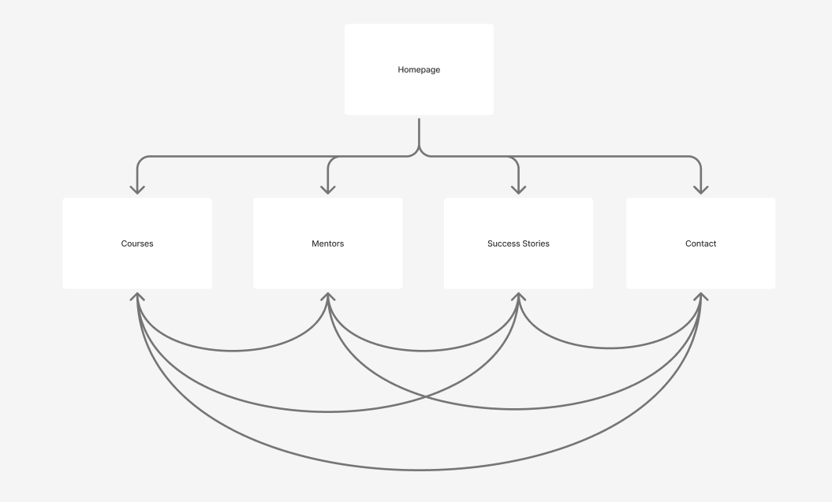

Content Outline
Fonts, colours, pages
Summary of text/media needed for each page.

Bibliography
https://gradnet.io/mentoring/ – mentors page inspo
https://nicepage.com/st/3115618/write-a-review-and-rate-website-template - success stories page
https://www.figma.com/ - sitemap
https://sovereignhousegh.com/blog/community-hubs - definition of community skills hub

